Tax Woman Email Guide

1. Go to http:// www.taxwoman.co.za  
   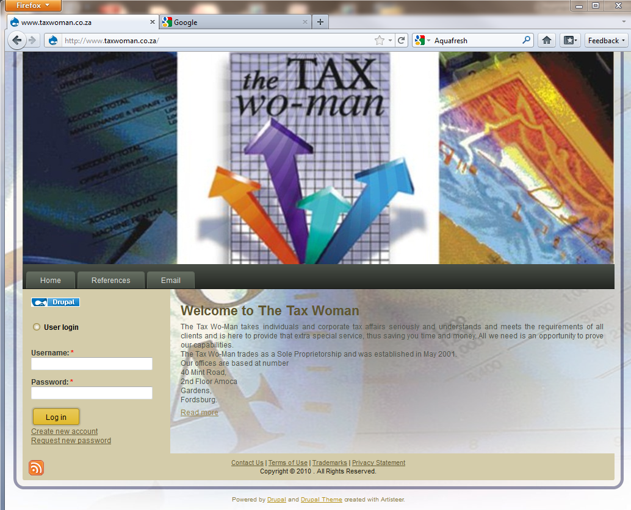
2. Click the Email Button.
3. This will open a dialog box that requests a username and password   
   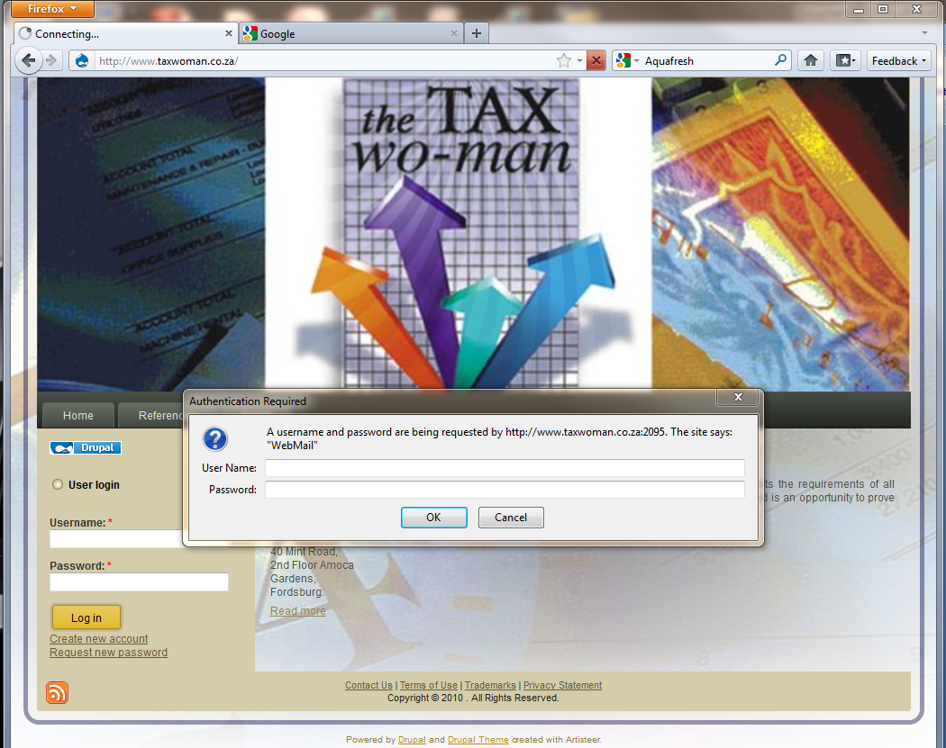
4. Type in your full email address i.e. "emailuser@taxwoman.co.za"
5. Fill in your password
6. If all goes well you should see a screen like this   
   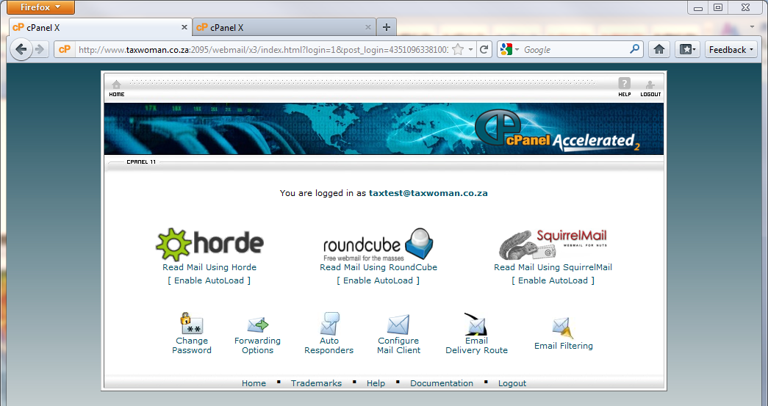
7. Click the "Roundcube" Icon.
8. This will take you to the following screen,
   1. where you can view your email.
   2. Send email

